 | Equity Research; Airlines in a ‘brave new world’
 | Research Report  Report Date  6th July 2020  Analyst  Ravi Lockyer MSc Llb ASCI  Collins Sarri Statham Investments Ltd  Key Risks to Price Target  Not applicable  Please note the risk warnings and disclaimers on the last page of this document. | EU Airlines – significant changes ahead  With re-opening underway over July, the August summer holiday has been saved. The list of UK “air bridge” countries at 75 provides plenty of choice in the EU, however North American destinations are limited to Canada.  Given the lockdown and financial uncertainty, Q2 2020 saw global demand collapse. According to International Air Transport Association (IATA) – the key RPK (revenue passenger kilometers ‘passenger traffic’) dropped 91.3% compared to May 2019. IATA forecast RPK at under 4bn in 2020 from 8bn in 2019.  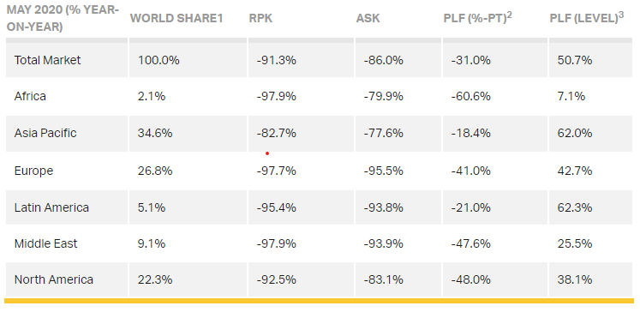  IATA May 2020; Domestic flights are down globally by 79.2% with China recovering fast. However Japan has been hit hard which given the limited impact of Covid-19 (,1,000 deaths) looks counter intuitive.  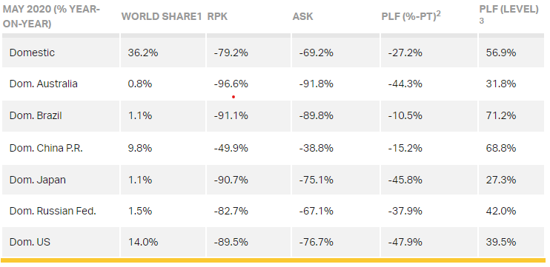  ASK ‘available seat kilometers’ i.e. the available passenger capacity suggests airlines are matching capacity with demand. Q2 is the ‘trough’ in demand i.e. the worst point.  ‘Staycations’ face a strong outlook with UK/ EU consumers taking the view that health problems, should they occur, are better managed at home. The UK government advice remains to avoid “all but essential international travel”. A change in Foreign office advice on international travel could occur in August 2020.  The airlines’ public response has been consistent that demand recovery (to 2019 levels) could take to 2022-2023. IATA do not expect a return to 2019 volumes until 2024. Restructuring activity is underway and early stage, with workforce and hub/ network reductions.  We view positively the judicial review (BA/ easyjet ad Ryanair v UK government) of the 14 day quarantine rule. The legal challenge is being heard on the 6th July 2020 with a decision shortly thereafter. We expect the UK government’s insistence on the 14 day quarantine (for UK returnees in place since 8th June 2020) as being “unreasonable” under the Wednesbury unreasonableness guidelines.  Statements from the airlines on forecast openings over Q3 and Q4 2020  Airline Resumption Date Forecast Capacity usage: July ‘20 Forecast Capacity usage: August ‘20  Dart Group 15th July - -  Easyjet 17 June 50% of normal 75% of normal  IAG 1 August (Gatwick) 50% of normal 70% (Q4 2020)  Ryanair 1 July 40% of normal (Q3 2020) -  Virgin Atlantic 20 July None provided -  TUI 11 July None provided -  Wizz Air 1 May None provided -  Recent Covid-19 data indicates a collapse in the transmission and mortality rate in western and central Europe (fewer than 300 deaths per day). The UK’s ‘air bridge’ re-openings (75 countries) reflect a higher confidence in travel to Western Europe over the critical July/ August period.  The international picture is uneven with stubbornly high new Covid-19 numbers in the US ‘sunbelt’ states (Texas/ Florida both have significant populations) Mexico and Brazil. The re-introduction of lockdown measures in Beijing is a concern which could derail the recovery in domestic flights to China and in neighboring Asian countries.  The Covid-19 data suggests recovery in European short haul flights will precede the trans-Atlantic/ trans-Pacific recovery. This is clearly beneficial for exclusively EU short haul operators, Easyjet, Jet2, Ryanair and Wizz Air.  Whilst investor expectations remain high that global air travel demand will have normalized by 2021 the industry is concerned about the implications of social distancing both at airports and onboard flights, and to a lesser extent about environmental lobby pressure on the sector’s weak ‘green’ credentials.  UK/ EU airlines have raised significant new cash  The UK/ EU airline industry has raised considerable new debt and equity funding since Covid-19 related lockdown and travel restrictions. Whilst cash levels appear sufficient and relatively high, the issue of recovery in travel demand remains.  Airline Liquidity (cash + bank facility) Covid Funding + Placing M&A/ Disposals Comment  Dart Group £1.5bn cash (18 March 2020) +£300m (BoE) £100m RCF +£172m (shares) +£98m Board lifted cash, facilities and receivables to £2.17bn. Further fund raising unlikely.  Easyjet £1.38bn cash (31 March 2020) but net debt £467m (hence gross debt £1.85bn) +£600m (BoE) +£400m (term loans) +£419m (shares) £301m (sale+ leaseback) EZJ expects another c. £200m via same route Board is reducing staff by 30% and has raised £1.7bn. EZJ expects i) 3M grounding costs £1bn ii) 6M grounding costs £2.1bn.  IAG €10bn (end April 2020- of which cash €6.9bn) – net debt €7.5bn +£300m (BoE) €1.01bn (Govt of Spain) Air Europa €1bn buy-out going ahead Operating costs c. €200m per week. Cash pressures are significant. Co likely to raise more funds  Ryanair €4.1bn cash (18th May 2020) +£600m (BoE) N/A Operating costs c. €60m per week in May. Cash pressures are manageable  TUI AG €1.04bn €1.8bn (Govt of Germany) €808m Hapag Lloyd sale funds due Operating costs c. €300m per month in May, TUI cannot get BoE support due to ‘junk’ rating.  Wizz Air €1.5bn cash (end March 2020) €728m net debt +£300m (BoE) N/A strong cash but no guidance. June traffic fell 86%, co has cut 19% staff  The airline sector’s significant cash post BoE and other government loan drawdowns and some new share issuance is likely the high- water mark for Covid-19 liquidity. Going forward into H2 2020 there is far more equity dilution risk if passenger travel does not stage a meaningful recovery over Q3 to forecast levels of demand of c. 50% of 2019 comparable period. There is limited data on travel refunds/ vouchers at leading airlines hence the expectation we expect cash levels to reflect pre-payments/ refunds and vouchers by Q3 2020.  How much time does current funding buy?  Current ‘cash burn’ forecasts suggest the airline sector has adequate cash levels for managing this environment for the remainder of 2020. A demand uptick would rapidly reduce cash burn over 2020.  Airline Liquidity (cash + bank facility) ‘Cash Burn’ estimate Months (Q2 conditions) Comment  Dart Group £2.17bn available c. £60m pcm >12 months Strong position  Easyjet c. £1.4bn available £330m pcm declining to £200m c. 6-9 months Weak position v peers especially RYA  IAG €8.2bn €866m pcm declining to €300m 9 -12 months IAG has not had an equity issue and fundraising has been modest. Overall position is ok  Ryanair €4.1bn cash (18th May 2020) €260m pcm >12 months Very strong position, equity issue unlikely  TUI AG €3.6bn €300m pcm 12 months Strong position  Wizz Air €1.8bn c.€100m pcm >12 months Very strong position, equity issue unlikely  Key will be the pace of travel demand recovery. If we assume that 2019 volumes will be at 70% by Q4 2020 and not return until 2023 (i.e. the IAG forecast) then the likely trajectory is between 70%-100% over 2021 and 2022. In my view this is built into current valuations.  However key risks remain elevated, including a second-wave necessitating further lockdowns, a lengthy UK/ EU recession and the implications of social distancing on airports/ air travel.  Whilst I feel more comfortable with Dart, Ryanair and Wizz, there is, in reality little differentiation with all players either totally exposed or heavily exposed to EU short haul. I want more evidence of demand recovery as I expect demand recovery will lag expectations certainly over the key July/ August period.  God Bless You and Stay Safe and Healthy!
Collins Sarri Statham Investments Ltd
Key to Material Interests:
Please be aware that the following disclosures of Material Interests are relevant to this research note:
Dart Group Relevant disclosures: <2>
Easyjet Relevant disclosures: <2>
IAG Relevant disclosures: <1,2>
Ryanair Relevant disclosures: <2>
TUI Relevant disclosures: <2>
Wizz Air Relevant disclosures: <2>

1. The analyst has a personal holding in the securities issued by the company or of derivatives linked to the price of the company’s securities.
2. Collins Sarri Statham Investments Ltd has clients who hold either shares or CFD positions in this security.
ANALYST CERTIFICATION:
The report’s author certifies that this research report accurately states his personal views about the subject securities, which is reflected in the ratings as well as the substance of the reports.
RECOMMENDATIONS:
Collins Sarri Statham Investments Ltd (CSS) does not in any of its publications take into account any particular recipient's investment objectives, financial situation, and specific needs and demands. Therefore, all CSS publications are, unless otherwise specifically stated, intended for informational and/or marketing purposes only.CSS shall not be responsible for any loss arising from any investment based on a perceived recommendation.
No publication (including recommendations) shall be construed as a representation or warranty that the recipient will profit, nor avoid sustaining losses, from trading in accordance with a trading strategy set forth in a publication.
This research is non-independent and is classified as a Marketing Communication under FCA rules detailed in their Conduct of Business Rulebook (COBS). As such it has not been prepared in accordance with legal requirements designed to promote independence of investment research and it is not subject to the prohibition of dealing ahead of the dissemination of investment research outlined in COBS 12.2.18.
RISK WARNING:
Trading in the products and services offered by Collins Sarri Statham Investments Ltd (CSS) may, result in losses as well as profits as the value of investments may go down as well as up. You may not get back the full amount you have invested. Any reference to past performance should not be viewed as an indication of any future performance. Investments held in overseas markets are subject to the effects of changes in exchange rates which will impact on the value of the underlying investment. Leveraged products such as Contracts for Difference (CFDs), derivatives, commodities & Foreign Exchange (FX), carry a higher risk to your capital and they can lose their value rapidly.
SPECULATIVE TRADING IS NOT SUITABLE FOR ALL INVESTORS.
The information contained herein is based on materials and sources that we believe to be reliable however we make no representation or warranty, either express or implied, in relation to the accuracy, completeness or reliability of the information contained herein. Please note that the figures shown may, in some instances, be rounded to the nearest penny. Prices can move sharply from those quoted in this document. Current prices can be verified by calling one of our brokers. CSS is under no obligation to update the information contained herein. Neither CSS, nor its affiliates, nor its employees shall have any liability whatsoever for any indirect or consequential loss or damage arising from the use of this document.

